**Final Project Proposal**

**Event Assistance Robots**

**Team: SF - PG3**

**Professor: Dr. Phillip Jones**

**Fall 2024, Section 7**

**CprE 2880**

**Team Members**

Soma Germano

Diego Cardona

Tanner Drabek

Patrick Musoy

Winson Vetsavong

Miles Nichols

**Table of Contents**

**Introduction 3**

Problem Statement 3

Application Narrative 3

**Empathy Maps 5**

Business Owner 5

Catering Servers 6

Chefs 7

Event Attendees/Customers 8

**Functional Requirement 11**

**Technical Details 13**

**Mapping Functional Requirements to Platform 15**

**Testing and Demonstration Plan 17**

1. Mapping Test Field Items to Application Narrative 17

2. Prototypes for Test Field Items 18

Testing Sketch 19

**Conclusion and Future Work 21**

**Team Contribution 23**

**User Research / Sources Cited 24**

## 

## **Introduction**

### **Problem Statement**

Managing events with high attendee turnout can be challenging, especially when event staff are understaffed and overwhelmed. This often leads to delays in food and drink service, causing frustration for attendees and stress for management. There is a need for an efficient solution that can autonomously handle deliveries, navigate obstacles, and ensure timely service, thereby improving the overall event experience for both staff and attendees.

### **Application Narrative**

Have you ever been at an event that felt poorly timed with food or drink service and thought to yourself, “I wish there were a quicker way to get my food?” If so, our EventBots are perfect for you. Events can become very hectic and stressful to manage, especially when there is a higher outcome of attendees than expected and when event management is understaffed. Our project aims to make it easier for management staff and consumers alike. Our embedded application can autonomously drive, scan, and avoid obstacles arriving at the selected location with delivery items and announcing their arrival. All the user has to do is turn on the bot, which will navigate to the destination. This application can be used for many different purposes and by many different users. Business Owners can use it to deliver items during an EventBots to send dishes back to the backend (chefs and kitchen staff).

## **Empathy Maps**

**Users**

1. Business owner
2. Catering Servers
3. Chefs
4. Event Attendees/ Customers

### **Business Owner**

**Empathy Map**

| **Think**   * Could this be the answer to our labor shortages and rising wages? * I wonder if customers will appreciate or resist this change * How much will this investment actually save me in the long run? | **Say**   * Hiring staff has been challenging and costly. * Customer experience is our top priority. * How will my regular customers react to a robot server? |
| --- | --- |
| **Do**   * Analyzes costs, maintenance needs, and potential ROI of robot servers * Actively searches for robot servers due to shortage in employees * Look at the possibility of becoming a trend setter in the restaurant business. | **Feel**   * Hopeful: Sees potential to alleviate staffing struggles and reduce costs. * Concerned: Worries about reliability, customer response, and hidden costs. * Curious: Interested in how a robot might improve or change the customer experience. |

**Point of View Statement**

* Business Owners need a solution to labor shortages because they need labor to run their business [1]- [3].

### **Catering Servers**

| **Think**   * “If this takes on basic tasks, I could focus more on customer interactions.” * “I hope the robot doesn’t create extra work for me.” * “Will customers be disappointed if a robot serves them instead of me?” * “I wonder if I’ll have to learn new skills to work with it.” * “This could help during rush hours, but I’m worried about how it’ll fit in with the team.” | **Say**   * “Will this robot replace my job?” * “How am I supposed to interact with it? Do I still need to serve tables the same way?” * “I hope it’s more helpful than a hassle.” * “Will customers think it’s strange?” * “How much time will this save me during peak hours?” |
| --- | --- |
| **Do**   * Adapts to new technology in the restaurant environment. * Observes and learns the robot’s functions to see how it can help with their tasks. * Explains the robot’s role to curious customers and addresses any customer questions or concerns. * Tests the robot to understand its capabilities and limitations. * Adjusts their workflow based on what the robot can handle (e.g., delivering food to tables or bussing) | **Feel**   * **Curious**: Eager to see how the robot works and if it really makes the job easier. * **Apprehensive**: Worries about job security and whether the robot might replace human roles. * **Hopeful**: Optimistic that the robot could reduce some workload, especially during peak times. * **Protective**: Cares about customer satisfaction and wonders if the robot will affect guest interactions. * **Adaptable**: Willing to learn and incorporate the robot into daily work if it proves beneficial. |

**Point of View Statement:**

* Servers need a way to handle repetitive tasks because they want to focus on providing excellent customer interactions [4]-[6].

### **Chefs**

| **Think**   * “What if a robot server could handle simple tasks, like bringing food to tables?” * I hope this investment will improve workflow and reduce stress for the kitchen and staff | **Say**   * “I need more time to focus on the food, not on delivering it.” * “We’re short-staffed, and it’s impacting our ability to provide excellent service.” * “Consistency is crucial, especially when it comes to customer interactions.” |
| --- | --- |
| **Do**   * Uses the server bot to serve the food * Assesses customer feedback to enhance food quality * Manages the staff`s schedule | **Feel:**   * Stressed: With the constant demands of food preparation and customer service. * Overwhelmed: By high turnover rates and the difficulty of finding reliable staff. * Curious: About whether robots could actually make a positive impact. |

**Point of View Statement**

* Chefs need a way to deliver dishes to tables and reduce workload because they need to focus entirely on food preparation [7]-[9].

### **Event Attendees/Customers**

| **Think**:   * ‘This is taking too long, is this even worth the wait’ * ‘I might leave if it takes too long’ | **Say:**   * “When will my food arrive?” * “What’s taking so long” |
| --- | --- |
| **Do:**   * Attends event, consumes products from business owner, * Interacts with the robot | **Feel:**   * Frustrated that goods are taking a while to be delivered/served * Satisfied with service once robot serves them in a timely manner |

**Point of View Statement**

* Event attendee needs faster service, as delays lead to frustration and doubt about the service’s value [10]-[12].

**User Need**

1. **Business Owners**
   * **Need:** A cost-effective solution to address labor shortages while ensuring high-quality service.
   * **Justification:** Business owners prioritize operational efficiency and customer satisfaction, which robotic systems can support by reducing dependency on hiring while delivering consistent performance.
   * **Scenario:** A business owner uses EventBots to serve food, drink and beverages during peak business hours, improving customer experience without overburdening staff.
2. **Catering Servers**
   * **Need:** Tools that handle repetitive tasks like delivering food to allow more focus on customer service and interactions.
   * **Justification:** Catering servers aim to enhance customer or human aspect of service while offloading basic, time-consuming tasks to automated systems.
   * **Scenario:** During a busy event, a catering server relies on EventBots to deliver dishes, enabling them to engage more with attendees and address specific needs or requests.
3. **Chefs**
   * **Need:** A system that ensures timely delivery of prepared dishes, meals, reducing the stress of managing both kitchen tasks and service demands of customers.
   * **Justification:** Chefs face challenges with maintaining consistency under pressure, staff shortages, and robotic delivery systems can improve workflow efficiency.
   * **Scenario:** EventBots autonomously transport meals from the kitchen to the service area, allowing chefs to concentrate on food preparation.
4. **Event Attendees / Customers**
   * **Need:** Fast and reliable delivery service to enhance their experience, particularly during busy times.
   * **Justification:** Long waits for food and drinks negatively impact attendee satisfaction. Automating service can ensure timely delivery and improve overall enjoyment of service.
   * **Scenario:** Even attendees receive foods and drinks within minutes via EventBots, avoiding frustration caused by any delays.

## **Functional Requirement**

| ***Core Functionality*** | ***Efficient Item Delivery*** | ***Feature*** | ***Necessity*** |
| --- | --- | --- | --- |
| ***Obstacle Avoidance*** | Detects Obstacles | EventBot uses ultrasonic and infrared sensors to detect and bypass obstacles | Ensure safety and smooth operation in crowded and dynamic |
| ***Dynamic Pathfinding*** | Adjust routes dynamically | Incorporates real-time navigation adjustments using proximity sensors and algorithms. | Handles unexpected environmental changes, such as a blocked path, to ensure successful delivery. |
| ***User Notification*** | Notifies upon arrival | It uses LED lights and a sound module to notify of its arrival or actions. | Keeps users informed and ensures items are correctly delivered without confusion. |
| ***Payload Security*** | Secures items | Provides secure compartments for carrying items like food or drinks. | Prevents spillage or item damage during transit, maintaining quality and safety. |
| ***User Control*** | User Activation | Activation through a physical switch or a mobile app interface. | Enables easy setup and operation, making the system user-friendly and accessible to non-technical users. |
| ***Destination Identification*** | Identifies delivery location | User QR code readers, RFID tags, or location markers to identify target locations. | Ensures items are delivered accurately, minimizing errors in delivery. |
| ***Autonomy*** | Functions as intended with minimal assistance | Once activated, EventBot can find its own path and reach the destination by itself | Keeps the goal of minimizing the need for human assistance |
| ***Reliability*** | Produces consistently intended results | Able to function without failure consistently. | A product must work as intended for consumer trust |

## Technical Details

**Big Picture of Events:**

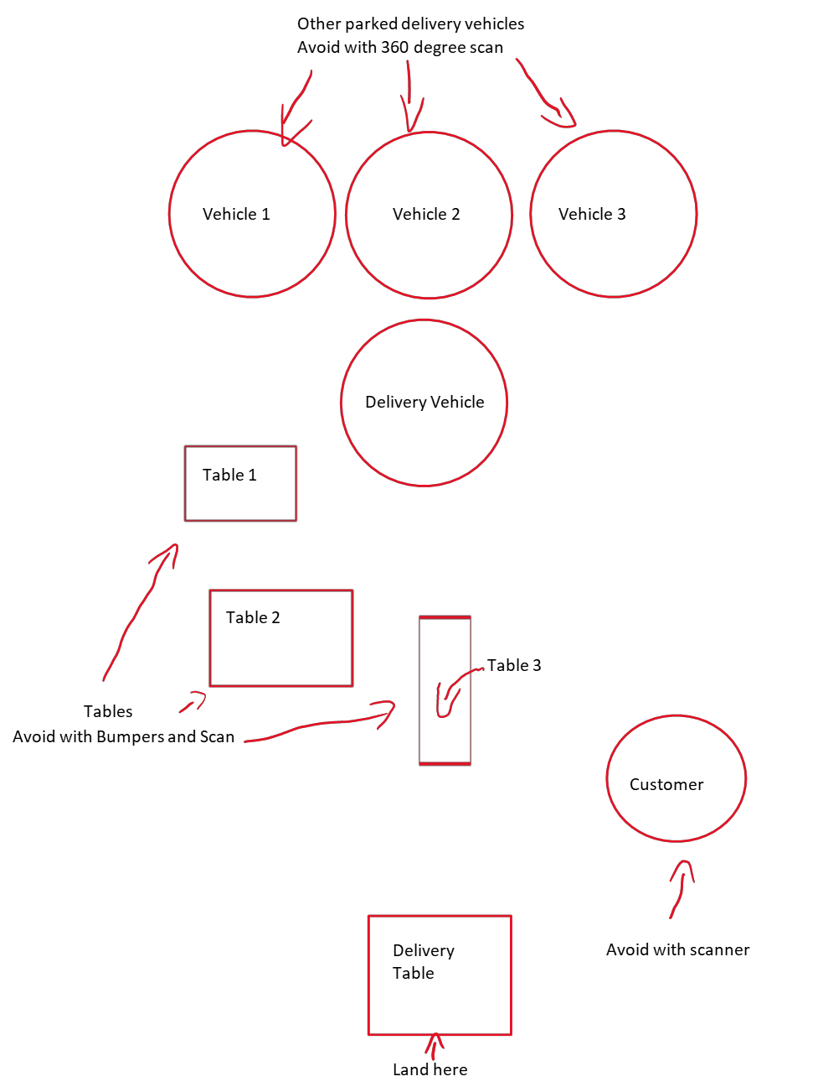

**Technical Sketches**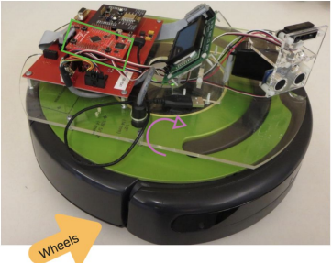

**Key Features:**

**Color green:** TM4C123GH6PM

Microcontroller: enables the

Roomba’s special features

**Color Purple**: Speaker: used to alert the

user of any actions or arrival

Color Orange: Wheels located under the

Roomba allow the

movement

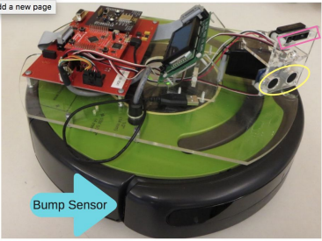

**Key Features: Detection**

**Color Purple:** IR Sensor: infrared

sensor for any object

detection

Color Yellow: Ping Sensor_sonar sensor

for any object detection.

**Color Blue**: Bump Sensor_detect when

the bot has run into

an object

### **Mapping Functional Requirements to Platform**

1. ***Function:***

* Each primary task the EventBot performs to fulfill the user and system requirements

1. ***Project Equivalent:***

* Specific behaviors or deliverables that align with the project goals.

1. ***Capabilities Used:***

* The hardware and software components (sensors, motors, LEDs, algorithms) are utilized to achieve each function.

1. ***Explanation or implementation:***

* Step by step mechanisms or methods used to achieve the required functionality.

| ***Function*** | ***Project Equivalent*** | ***Capabilities Used*** | ***Explanation*** |
| --- | --- | --- | --- |
| **Autonomous Driving** | Navigate autonomously to destinations | Motorized platform, pre-programmed routes, and navigation logic | Pathfinding algorithm combined with motorized wheels |
| **Obstacle Avoidance** | Avoid obstacles in the environment | Ultrasonic and IR sensors | Ultrasonic and infrared sensors detect and reroute dynamically |
| **Item Delivery** | Deliver items safely to a destination | Motorized platform with secure payload storage | Payload compartment secured during transit |
| **Announcing Arrival** | Notify the user upon reaching the location | LEDs and sound modules | LED indicators and sound modules |
| **Dynamic Path**  **Adjustment** | Adjust the path for unexpected changes | Proximity sensors and real-time processing | Real-time navigation recalibration based on sensor input |
| **User Activation** | Start and stop robot operations | User interface with manual or mobile control | Manual switch or app-based activation |

## Testing and Demonstration Plan

## **Mapping Test Field Items to Application Narrative**

Each test field item has been designed to align closely with the application’s core functionalities as described in the narrative. The following table outlines these mappings.

| ***Core Functions*** | ***Application Narrative*** |
| --- | --- |
| **Obstacle Avoidance** | EventBot is able to avoid water spills, dropped food, chairs and people in the dining area |
| **Dynamic Pathfinding** | EventBot can navigate around obstacles in the dining room |
| **Payload Security** | EventBot can carry food to a dining table |
| **Announcing Arrival** | EventBot can notify customers the food has arrived at the table |
| **Destination Identification** | EventBot is able to correctly identify a table from other objects in the dining room |

***Mapping Test Field Elements to Application Narrative***

| ***Basic Test Field Objects*** | ***Mapping to Application Narrative*** |
| --- | --- |
| **Tall Wide Object** | People in the dining area |
| **Short Objects** | Dropped food in the dining area |
| **Pillars (Tall Thin Objects)** | Chairs |
| **Holes** | Water spill in the dining area |
| **Out of Bounds** | Outside of the dining area (backstage or restricted area) |
| **Destination Zone** | Table to be served |

***CyBot Capability and Integration***

| ***Base Functionality*** | ***CyBot Capability*** | ***Project Usage*** |
| --- | --- | --- |
| Cybot Communication | WiFi / UART | EventBot needs the ability to communicate data from the EventBot because of start commands |
| Cybot Movement | Open Interface (Robot Movement) | EventBot needs to be able to move because it needs to navigate around the dining room |
| Object Detection | Analog to Digital Conversion | EventBot needs infrared and ultrasonic sensors because it needs to be able to detect real-world elements |
| Obstacle Avoidance | Interrupts | EventBot needs the ability to obstacles because it has to get to the destination effectively |
| Boundary Adherence | Input Capture | EventBot needs to stay within bounds because its job is within the dining room and kitchen |
| Arrival at Destination | Pulse Wave Modulation (PWM) | EventBot needs to differentiate when it is at the intended destination because it has to serve a table |

### **Prototypes for Test Field Items**

To support the testing plan, prototypes have been developed for the following components:

* **Sensor Array**: Includes ultrasonic and infrared sensors to detect obstacles and enable dynamic pathfinding.
* **Payload Compartment**: Secure storage designed to prevent spills or damage during movement.
* **Notification System**: LED and sound module prototype to alert users upon delivery.
* **Obstacle Detection System**: Combines ultrasonic and infrared sensors to detect and avoid obstacles of varying shapes and sizes.
* **Boundary Adherence Mechanism**: Uses input capture and sensor feedback to ensure the bot remains within defined operational areas.
* **Payload Delivery System**: A secure compartment with precision stopping mechanisms (PWM) to facilitate safe and accurate delivery.

### **Testing Sketch**

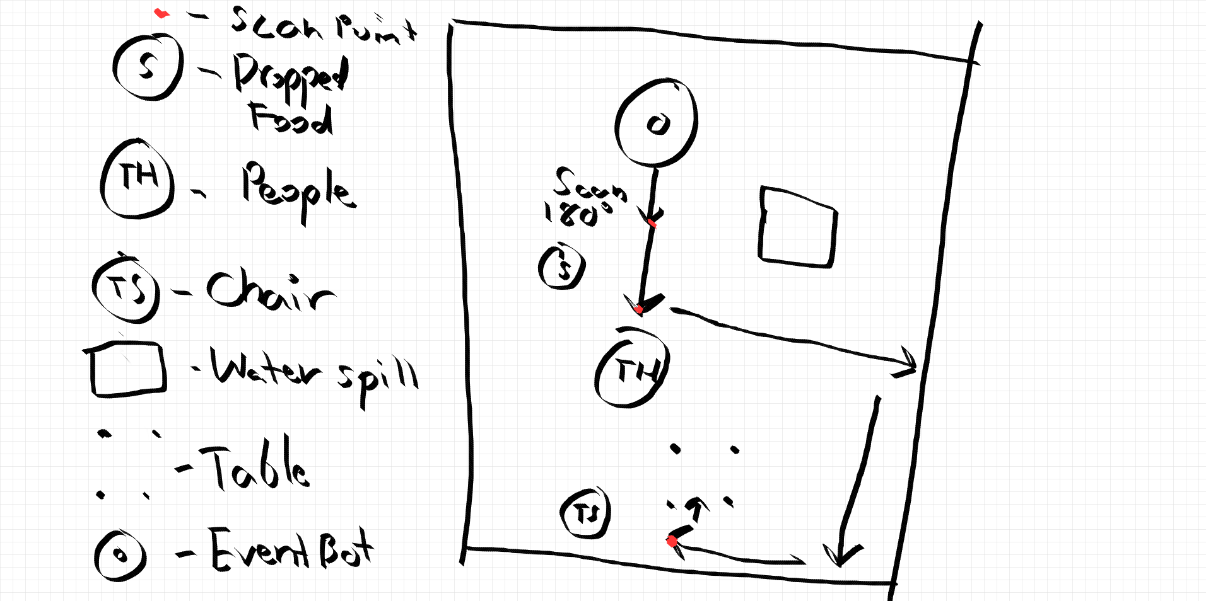

1. **Demonstration Narrative**

The testing and demonstration plan will validate the functionality of EventBots in a simulated environment that mimics real-world conditions. The following steps will be followed:

* **Initialization**:
  + EventBot will be activated using the mobile application or physical interface.
* **Navigation**:
  + The robot will autonomously navigate through a test field with tall objects, small obstacles, and narrow pathways, adjusting its path dynamically based on sensor feedback.
* **Boundary Adherence**:
  + The system will demonstrate its ability to stay within operational limits while avoiding out-of-bound zones and drops.
* **Item Delivery**:
  + EventBot will successfully transport payloads to the designated zone, notify the user of its arrival through LEDs and sound signals, and ensure secure delivery.
* **Data Collection**:
  + Performance metrics will be recorded and analyzed, including navigation efficiency, obstacle avoidance success rate, and delivery accuracy.

This testing approach will ensure that EventBots meet functional and user-centric requirements, paving the way for successful deployment in diverse event environments. The successful deployment of EventBots has the potential to revolutionize event management by addressing critical pain points and setting a new standard for automation in service industries. The insights gained from real-world validations and iterative development will guide the journey towards a more efficient, reliable, and user-friendly solution.

**Real-World Validation**

Real-world case studies highlight robotic systems' growing acceptance and effectiveness in service-oriented industries. For example, the "Servo" robots deployed by Bear Robotics have successfully reduced wait times and staff stress during peak restaurant hours. Similarly, Hilton’s "Connie" concierge robot demonstrated the potential of automation to streamline guest interactions and improve operational consistency. These examples validate the viability of integrating robotics into environments with high customer engagement.

However, these implementations also underscore key challenges that must be addressed, such as ensuring reliability in dynamic environments, maintaining a balance between automation and the "human touch," and overcoming initial customer resistance to robotic technologies. EventBots incorporates these lessons through features like dynamic pathfinding, secure payload compartments, and customizable user notifications to mitigate such barriers.

## **Conclusion and Future Work**

The development of EventBots represents a significant step forward in leveraging robotic solutions to address labor shortages and improve operational efficiency in the event management and hospitality industries. By focusing on autonomous navigation, obstacle avoidance, and user-friendly interfaces, this project aims to deliver practical, scalable technology that enhances customer satisfaction and alleviates staff workload.

**Future Work**

To further develop and validate the EventBots system, the following steps are planned:

* **Pilot Testing at Live Events**: Conduct small-scale deployments of EventBots in real-world event scenarios. These pilot tests will gather data on system performance, user satisfaction, and operational efficiency, providing critical feedback for refinement.
* **Enhanced User Interaction Design**: Based on customer feedback from case studies, future iterations will explore improved interaction models to maintain the "personal touch" in customer experiences. This may include voice interfaces or adaptive behaviors based on customer preferences.
* **Scalability and Cost Optimization**: Investigate ways to optimize the hardware and software to make the system more accessible for small- and medium-sized event businesses. Collaboration with industry partners will also explore opportunities to scale production and reduce costs.
* **Extended Use Cases**: While the current focus is on event management, future work will explore applications in other sectors, such as healthcare, education, and retail, where similar logistical challenges and user needs exist.
* **Continuous Performance Monitoring**: Develop metrics to evaluate the long-term impact of EventBots on operational efficiency, labor costs, and customer satisfaction. This will help ensure that the system remains relevant and effective in evolving market conditions.

## **Team Contribution**

| ***Team Member*** | ***Team Contribution*** |
| --- | --- |
| **Soma Germano** | Application Narrative, Problem Statement, Event Attendee Research, Movement and Scanning, Sound |
| **Diego Cardona** | Researched and wrote empathy maps, GUI |
| **Tanner Drabek** | Movement and Scanning, Code testing |
| **Patrick Musoy** | Edit & Review Proposal Document, Draft and Integrate Conclusion, Future Work, and Testing Plan Section. |
| **Winson Vetsavong** | Works Cited, Proposal Quality Assurance, Table of Contents, Elevator-Pitch video, Mapping Test Field Elements to Application Narrative, re-drew testing sketch to fit application narrative |
| **Miles Nichols** | Drafted big picture and test sketches, Holes Detection, Boundary Detection, and Destination Detection and logic. |

## 

## **User Research / Sources Cited**

[1] Naperville Community Television NCTV17, “Robotic Chef Serves Up Meals At Naperville Food Court,” *YouTube*, Nov. 24, 2021. https://www.youtube.com/watch?v=Gh1q7tldPhk (accessed Nov. 22, 2024).

[2] A. Allen, “Restaurant Robotics: How Robots Are Changing Foodservice,” *Aaron Allen & Associates, Global Restaurant Consultants*, Jul. 29, 2022. https://aaronallen.com/blog/restaurant-robotics

[3] P. Gross, “Data, pilot projects showing food service robots may not threaten jobs • Missouri Independent,” *Missouri Independent*, Oct. 02, 2024. https://missouriindependent.com/2024/10/02/data-pilot-projects-showing-food-service-robots-may-not-threaten-jobs/

[4] CBS Evening News, “California restaurant uses robot to deliver food, clear dishes,” *YouTube*, Apr. 28, 2024. https://www.youtube.com/watch?v=QRwYt8boz68 (accessed Dec. 15, 2024).

[10] O. El-Said and S. Al Hajri, “Are customers happy with robot service? Investigating satisfaction with robot service restaurants during the COVID-19 pandemic,” *Heliyon*, vol. 8, no. 3, p. e08986, Mar. 2022. doi: 10.1016/j.heliyon.2022.e08986.

[5] Washington State University, “Robot-phobia could exacerbate hotel, restaurant labor shortage,” *WSU Insider*, 2024. https://news.wsu.edu/press-release/2024/05/20/robot-phobia-could-exasperate-hotel-restaurant-labor-shortage/

[6] S. Brown, “A new study measures the actual impact of robots on jobs. It’s significant,” *MIT Sloan Management Review*, Jul. 29, 2020. [Online]. Available: https://mitsloan.mit.edu/ideas-made-to-matter/a-new-study-measures-actual-impact-robots-jobs-its-significant. [Accessed: Dec. 14, 2024].

[7] S. Choi and L. Wan, “The rise of service robots in the hospitality industry: Some actionable insights,” *Boston Hospitality Review*, Oct. 4, 2021. [Online]. Available: https://www.bu.edu/bhr/2021/10/04/the-rise-of-service-robots-in-the-hospitality-industry-some-actionable-insights/. [Accessed: Dec. 14, 2024].

[8] Chloë Mesogitis, “Wintersville’s Chef’s Table introduces ‘Peaches’, the robot server, to combat labor

shortages and enhance customer experience,” *WTOV*, 2022. https://wtov9.com/news/local/wintersvilles-chefs-table-introduces-peaches-the-robot-server-to-combat-labor-shortages-and-enhance-customer-experience (accessed Dec. 15, 2024).

[9] D. Ewing-Chow, “Here Are Five Global Restaurants Staffed By Robot Chefs,” *Forbes*, Mar. 31, 2024. https://www.forbes.com/sites/daphneewingchow/2024/03/31/here-are-five-global-restaurants-staffed-by-robot-chefs/

[10] X. Zhang, M. S. Balaji, and Y. Jiang, “Robots at your service: value facilitation and value co-creation in restaurants,” *International Journal of Contemporary Hospitality Management*, vol. 34, no. 5, pp. 2004–2025, Mar. 2022, doi: https://doi.org/10.1108/ijchm-10-2021-1262.

[11] ABC Action News, “Local restaurant using robot waiter,” *www.youtube.com*, 2022. https://www.youtube.com/watch?v=tJaj3_54S_E

[12] Voice of America, “Restaurant with robot servers causes excitement in Nairobi | VOA News,” *YouTube*, Aug. 15, 2024. https://www.youtube.com/watch?v=FVJy4B74ucs